
BOARD OF TRUST
DATE: Tuesday, October 28, 2025
In the Boardroom
TIME: 5:00 p.m.

PRESENT: Ms. D. Westcar (Acting Chair), Ms. A. Fortin, Mr. W. Gruszka, Ms. P. Hilderley, Mr. R. Mitchell, Ms. J. Soden, Mr. D. Wallet, Ms. B. Taylor (Pt. Advisor), Mr. P. Lang, Ms. C. Smart, Ms. S. Wolfe, Dr. M. MacLeod, Dr. P. Howatt, Ms. K. Lavelle, Mr. E. Andreola, Mayor J. Acchione (County Rep), Mr. E. Heiras, Ms. S. Young (Admin Resident)
REGRETS: Ms. T. Crockford, Mr. B. Kennedy, Ms. L. Symons, Dr. R. Humphrey, Dr. I. Hons, Ms. C. Lauder (City Rep)
Recorder: Ms. H. Scherer (Executive Assistant)

AGENDA ITEMS | DISCUSSION
CALL TO ORDER | The meeting was called by Ms. Westcar, Acting Chair at approximately 5:00 p.m.
LAND ACKNOWLEDGMENT | Ms. Westcar read aloud the land acknowledgment.
PRESENTATION | Accreditation Update:  Ms. S. McKay, Emergency Preparedness Lead, Accreditation Specialist and Policy Consultant presented the changes to the Accreditation process and highlighted the following:  - Next Accreditation is scheduled for 2028.  - Required Organization Practices (ROPs) are now known as Required Safety Practices (RSPs). We used to have 38 ROPs and there are now 24 RSPs, with 4 of those being new.  - Accreditation will be completed throughout four years. The first two years will include completing the self-assessment (review each department and standards) and survey instruments. Year three will be the completion of the Attestation (confirming compliance with key criteria related to policies, procedures and service delivery). The Attestation must be submitted 6 months before the on-site survey.  - The onsite assessment is conducted in year four and the organization will not know when the Accreditors are coming. Therefore, there will no longer be set meetings with the Accreditors, other than they will still meet with the Board, Senior Team and the Community Focus group. Their focal point will be meeting with front line staff and families.  - There are four decision guidelines/core components (core criteria, service criteria, RSPs and survey instruments). Based on those findings, organizations will be given Not Accredited, Conditional Status or Accredited.  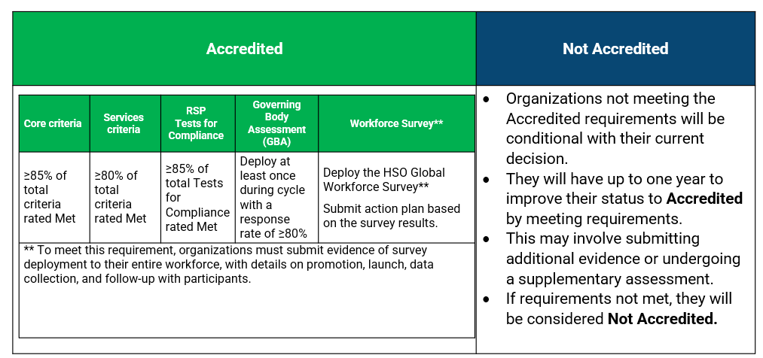  - The Board will complete the governance self-assessment survey prior to the November Board meeting. If you are unable to attend, a link will be sent to complete at home.  - In response to a question, it was noted that they believe the reason for not knowing when the Accreditors are coming is because organizations should be prepared and educating staff on all areas continuously, not just the 12 months leading up to their Accreditation.  - In response to a question, it was noted that the hospital does not receive funding for Accreditation. However, organizations that are accredited demonstrate a commitment to best practices in patient care, risk management, infection control and overall safety, which leads to better health outcomes and a safer environment for patients.  Ms. Westcar thanked Ms. McKay for her informative presentation.
DECLARATION – CONFLICT OF INTEREST | No one declared a conflict of interest.
ADOPTION OF AGENDA | MOVED by Mr. Acchione to adopt the agenda as circulated, seconded by Ms. Hilderley. CARRIED.
HUDDLE | Alternate Level of Care:  Ms. Westcar presented on Alternate Level of Care and highlighted the following:  - Alternate Level of Care (ALC) is a clinical designation for a patient occupying a hospital bed who no longer requires the intensity of services and resources provided in that care setting.  - Clinical decision must be designated by a physician.  - ALC patients can be waiting for:  - Long term care  - Home care  - Post-acute care (complex continuing care, rehab)  - Retirement home  - Group home/Transitional living  - Hospice  - Once a patient is ALC, the physician no longer is required to assess the patient daily. Nursing care does not change and any changes in medical condition will be reported to the physician.  - ALC can be an issue as it delays discharges, impacts hospital capacity, increases costs and impacts patients’ health.  - ALC patients waiting for long-term care pay a co-payment fee to cover the cost of room and meals.  - Co-payment only starts once the patient and/or family sign for long term care placement. The fee is determined by the Ministry of Health and I s subject to change based on the patient’s notice of assessment.  - The maximum rate effective July 1, 2025, is $68.56/day or $2,085.37/month.  - Annually, revenue is approximately $250K.  - The hospital regularly tracks the number of ALC days and the percentage of patient days that are ALC.
PREVIOUS MINUTES –  September 30, 2025 | MOVED by Ms. Taylor, seconded by Ms. Soden to approve the previous minutes of September 30, 2025. CARRIED.
Patient and Family Advisory Committee | Ms. Taylor reported that at their meeting they watched a video, Greg’s Wings – Falling through the Cracks and had a Q and A with Greg’s father and sister following the video. The video is Greg’s journey through the healthcare system in Alberta and how he fell through the cracks and ultimately passed away.  She also noted, that they are always looking for new patient advisors and if you know of anyone interested, please pass their name onto Jenn Lynch.  MOVED by Ms. Taylor, seconded by Ms. Hilderley to approve the previous minutes of September 17, 2025. CARRIED.
BUSINESS ARISING | Analysis of Conservable Bed Days:  At last month’s meeting, the Board Huddle was given on conservable bed days, and it was requested seeing the actual number of patients who stay longer and the reasoning. Data was shown on the number of conservable bed days for the last two fiscal years, the percentages of conservable bed days and the top clinical groups with discharges with conservable bed days.
City Report | No report
County Report | Mr. Acchione reported that he had a call with Minister Tibollo, Minister of Attorney Generals Office, but was the previous Minister of Mental Health as he was inquiring about the status of our HART Hub. He has a meeting with Minister Tibollo next month.
Foundation Report | Ms. Westcar provided the following update:  - The Foundation Board had a presentation from John McLaverty and Associate, Capital Campaign Consultant, who will be conducting a feasibility study for the HART Hub. They will present back to the Foundation Board in February on their campaign plan.  - The Foundation received $100,000 from Beatice Mackie’s estate.  - The grand prize winner of the September 50/50 was Ferdinand LaGro who took home $45,642. Ferdinand and his wife brought in a cheque of their own for the Foundation with a donation of $10,000.  - The October 50/50 grand prize draw is this Friday.  - November marks the fifth anniversary of the 50/50 program. They will be offering 4 early bird prizes of $500 cash and one early bird prize of $5,000 cash.  - The chemo clinic’s grand opening was a success. All but two of the donors were able to attend the event and had their picture taken with their plaques.  - This year’s winter direct mail will be supporting cataract microscopes for surgical services.
Correspondence | No report
Adjournment | The meeting adjourned to LPP on motion at 5:32 p.m. CARRIED.

_____________________________________ ___________________________________
Ms. D. Westcar, Acting Chair Ms. L. Symons, Secretary

